**CSE102L Computer Programming Lab**

**LAB # 10**



**2020**

**Submitted to:**

**Engr. Abdullah Hamid**

**Submitted by:**

**TAYYABA**

**Registration No :**

**19PWCSE1854**

**Semester: 2nd**

**Class Section:** **C**

“On my honor, as student of University of Engineering and Technology,

I have neither given nor received unauthorized assistance on

this academic work.”

**August , 5, 2020**

**Department of Computer Systems Engineering**

**University of Engineering and Technology, Peshawar**

**Data Structures**

# Task 1:

## Title:

Write a program where you take area code, exchange and number from user and stores in data structure……

## Code:

#include<iostream>

#include<cstring>

using namespace std;

struct phone

{

char area[4];

char exchange[4];

char num[4];

};

int main()

{

struct phone my, usr;

strcpy(my.area, "096");

strcpy(my.exchange, "890");

strcpy(my.num,"3294");

cout<<"Enter your 3 digit area code: ";

cin>>usr.area;

cout<<"Enter you 3 digit exchange code: ";

cin>>usr.exchange;

cout<<"Enter your 4 digit number: ";

cin>>usr.num;

cout<<"\n\nMy number is ("<<my.area<<") "<<my.exchange<<"-"<<my.num<<endl;

cout<<"User number is ("<<usr.area<<") "<<usr.exchange<<"-"<<usr.num;

return 0; }

**Output**:

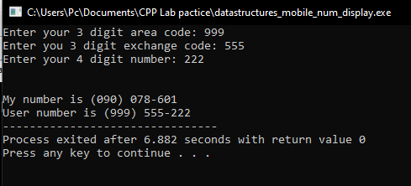

# Task 2:

## Title:

Create a movie database structure containing two members (title and year) for test run assign three movies and display their title and years.

## Code:

#include<iostream>

#include<cstring>

struct movie {

char title[20];

int year;

};

using namespace std;

int main()

{

struct movie m1, m2, m3;

strcpy(m1.title, "Harry Potter");

m1.year = 2000;

cout<<"Enter a movie name: ";

cin>>(m2.title);

cout<<"Enter "<<m2.title<<"'s year of release: ";

cin>>m2.year;

cout<<"Enter a movie name: ";

cin>>(m3.title);

cout<<"Enter "<<m3.title<<"'s year of release: ";

cin>>m3.year;

cout<<"\n\nMovie Name\t\t\tMovie Year\n";

cout<<m1.title<<"\t\t\t"<<m1.year<<endl;

cout<<m2.title<<"\t\t\t"<<m2.year<<endl;

cout<<m3.title<<"\t\t\t"<<m3.year<<endl;

return 0;

}

**Output**:

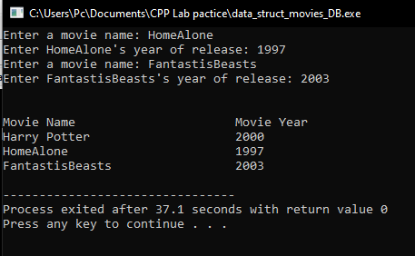

# Task 3:

## Title:

A point in 2D plane has X and Y coordinates. Write a program having a structure named point and draw rectangle of ‘*’ (asterisk) using the given width and height of point.

## Code:

#include<iostream>

using namespace std;

struct Point {

int x;

int y;

};

int main() {

struct Point point;

cout<<"Enter width: ";

cin>>point.x;

cout<<"Enter height: ";

cin>>point.y;

cout<<"Your pattern is :\n"<<endl;

for(int vertical = 0; vertical < point.y; vertical++)

{ cout<<"\t";

for(int horizontal = 0; horizontal < point.x; horizontal++)

{cout<<"* ";}

cout<<"\n";

}

return 0;

}

**Output**:

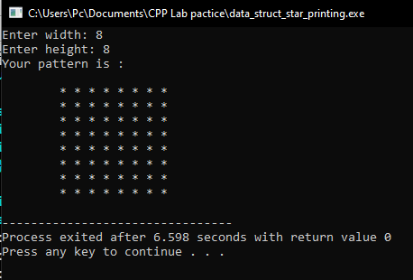

# Task 4:

## Title:

Write a program having a structure with members name, reg and semester. The user should enter for 5 students and then search the student data by registration number.

## Code:

#include<iostream>

using namespace std;

struct Student_t

{

char name[20]; int reg;

int semester;

};

int main()

{

int reg;

bool found = false;

struct Student_t arr[5];

for(int i = 0; i < 5; i++) {

cout<<"Enter Student's Name: ";

cin>>(arr[i].name);

}

for(int i = 0; i< 5; i++) {

cout<<"Enter "<<arr[i].name<<"'s Reg no: ";

cin>>arr[i].reg;

cout<<"Enter "<<arr[i].name<<"'s Semester: ";

cin>>arr[i].semester;

}

cout<<"\n\nSearch a student by his Reg No: ";

cin>>reg;

for(int i = 0; i < 5; i++) {

if(arr[i].reg == reg) { found = true;

reg = i; break;

}

}

if(found) {

cout<<"\n\nStudent Name: "<<arr[reg].name<<endl;

cout<<"Student Reg No: "<<arr[reg].reg<<endl;

cout<<"Student Semester: "<<arr[reg].semester;

}

else {

cout<<"No record found against this reg no.";

return 0; } }

## Output:

